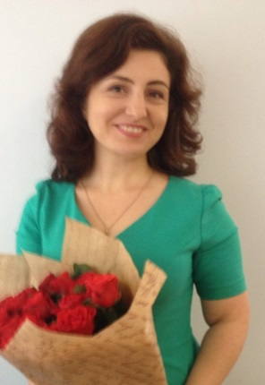  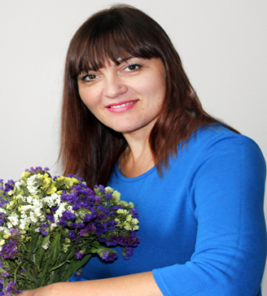 | OLENA KOKHAN  lkohana@ukr.net  Assistant Professor of the Department of Foreign Philology and Translation  Profile of the scientist in international bases:  ResearcherID, Google Scholar, ORCID  RESEARCH EXPERTISE: use of information and communication technologies (ICT)of learning in foreign language teaching  COURSES: English for Specific Purposes

ACADEMIC DEGREES:
• Ukrainian Institute of Linguistics and Management,2005
• National Pedagogical University named after M. Dragomanov, 1996

ACADEMIC APPOINTMENTS:
• Assistant Professor of the Department of Foreign Philology and Translation, KNUTE, since 2018
• Assistant Professor of the Department of Foreign Languages for Specific Purposes, NUFT, 2005-2018

LIST OF PUBLICATIONS:
https://scholar.google.com.ua/citations?user=No0iMzAAAAAJ&hl=uk

ADDITIONAL ACTIVITIES:
•Member of the International Association of Teachers of English as a Foreign Language, Ukraine (IATEFL).

HOBBY:
• Reading, psychology, theatre

