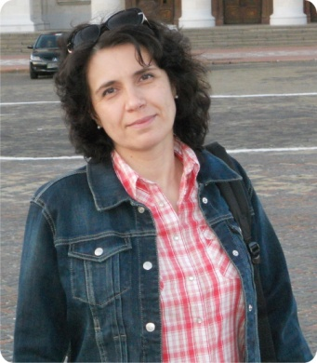 | OLHA DUBININA  dubinina_olga@ukr.net  Senior Lecturer, Department of Foreign Philology and Translation  Scientist profile:  Google Академія ORCID ResearcherID  RESEARCH EXPERTISE: innovative technologies in English language teaching  COURSES: “English for Specific Purposes”, “Business English”, “Practical English Course”
ACADEMIC DEGREES:
- Specialist, Pereiaslav-Khmelnytskyi Hryhorii Skovoroda State Pedagogical University, 1996
ACADEMIC APPOINTMENTS:
- Senior Lecturer, Department of Foreign Philology and Translation, Kyiv National University of Trade and Economics, 2012 – 2019
- Lecturer, Department of Foreign Languages, Kyiv National University of Trade and Economics, 2006 – 2012
AWARDS AND HONORS:
- Certificate of Appreciation for excellence in scientific and pedagogical work, Kyiv National University of Trade and Economics, 2016
- Certificate of Appreciation for conscientious and fruitful work, Kyiv National University of Trade and Economics, 2013
LIST OF PUBLICATIONS:
- Dubinina O., Moisiienko O. English for Specific Purposes. Tasks for the Development of Students’ Communication Skills / O. Dubinina, O. Moisiienko. – K. : KNUTE, 2016. – 73 p.
- Dubinina O. Let’s Speak English / O. Dubinina. – K. : KNUTE, 2016. – 126 p.
- Dubinina O. Practical Grammar of English: Manual / O. Dubinina. – K. : KNUTE, 2013. – 220 p.
- Dubinina O., Makarova O. Practical English Course. Tasks for the Development of Students’ Speaking Skills / O. Dubinina, O. Makarova. – K. : KNUTE, 2010. – 63 p.

Google Академія

ADDITIONAL ACTIVITIES:
- Member of the International Association of Teachers of English as a Foreign Language, Ukraine (IATEFL), 2018 – 2019
HOBBIES: reading, travelling, theatre.

