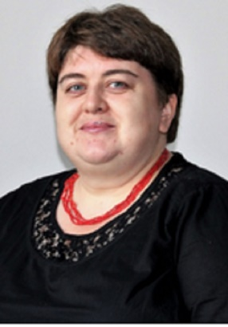 | LIUDMYLA VLASENKO  LyudaVlasenko@ukr.net  Teacher of the Department of Department of Foreign Philology and Translation  Profile of the scientist in international bases:  ResearcherID, Google Scholar, ORCID  RESEARCH EXPERTISE: covers problems of using of informatively-communicative technologies for the study of foreign languages  COURSES: “”, “”
ACADEMIC DEGREES:
- Kyiv National Linguistic University, 2004
ACADEMIC TITLES:

ACADEMIC APPOINTMENTS:

Senior Teacher of the Department of Business Foreign Language and International Communication, National University of Food Technologies, 2004-2018

Teacher of the Department of Foreign Philology and Translation, Kyiv National University of Trade and Economics, 2018 – present

AWARDS AND HONORS:
LIST OF PUBLICATIONS:
https://scholar.google.com.ua/citations?user=DomoCxUAAAAJ&hl=ru
ADDITIONAL ACTIVITIES:
HOBBY: reading, traveling, games of skill.

