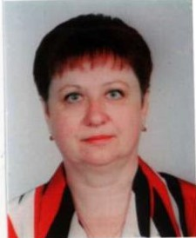
LARYSA KOVALENKO
Assistant Professor of the Department of Foreign Philology and Translation
lorchenkovalenko@gmail.com
Profile of the scientist in international bases:
Researcher ID, ORCID, Google Scholar
RESEARCH EXPERTISE: contemporary methodologies of German teaching
COURSES: “German for Specific Purposes”, “Practical Course of the Second Foreign language” “The Second Foreign language”.
ACADEMIC DEGREES:
Kyiv National Linguistic University, 1982.
ACADEMIC APPOINTMENTS:
Assistant Professor of the Department of Foreign Philology and Translation, KNUTE, since 1993
Lecturer of the Department of Foreign Languages, KNUTE, 1987-1993
AWARDS and HONORS:
- Kyiv National University of Trade and Economics Gratitude on high professionalism, 16.05.2005.
- Kyiv National University of Trade and Economics Gratitude on high professionalism, 08.04.2010.
- Kyiv National University of Trade and Economics Gratitude on high professionalism, 21.04.2010.
LIST of PUBLICATIONS:
- German for Economists / L. Kovalenko, - K: KNUTE, 2013 – 176 p.
- Essential German for Economists / L. Kovalenko, V. Galagan, K.: KNUTE, 2009 – 205 p.
- Business German / L. Kovalenko, N. Strokan, - , K.: KNUTE, 2007 – 275 p
- German of Economics, Accounting, Trade and Banking / L. Kovalenko /
V. Galagan, L. Miga, N. Strokan, - K.: KNUTE, 2004, - 320 p
- German – Ukrainian Terminology Dictionary of Trade and Economics /
L. Kovalenko / V. Galagan, L. Miga, N. Strokan, - K.: KNUTE, 2000
ADDITIONAL ACTIVITIES:
Head of the Section of the German Language of the Department of Foreign Philology and Translation, KNUTE
HOBBIES: reading, foreign languages, theatre, cinema

