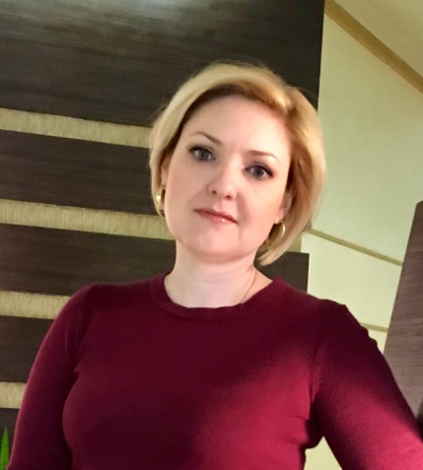 | OLGA ZHURKOVA  zhurkovaolga@ukr.net  Candidate of Philological Sciences (PhD)  Lecturer of English at the Department of Foreign Languages and Translation

Profile of the scientist in international bases:
Web of Science, ResearcherID, ORCID

RESEARCH EXPERTISE: covers problems of lexical semantics, stylistics, and communicative linguistics, the theory of nomination, pragmalinguistics, psycholinguistics, nonverbal semiotics, and linguaculture.

COURSES: “Practical English Course”, “Foreign language (English) of Professional Direction”, “Practice of Translation”.

ACADEMIC DEGREES:
- PhD in Comparative-Historical and Typological Linguistics, Kyiv National Linguistic University, 2019
- MS, Kyiv National Linguistic University, 2005
- BS, Kyiv National Linguistic University, 2004

HOBBY: trips, music, literature, cookery.

