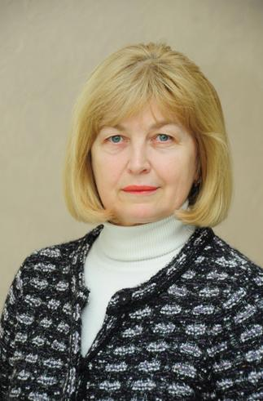
TETIANA KLYMENKO
taklim@bigmir.net
Senior Lecturer of the Department of Foreign Philology and Translation
Profile of the scientist in international bases:
ResearcherID, Google Scolar, ORCID

RESEARCH EXPERTISE: covers problems of the use of innovation teaching methods, use of interactive technologies.
COURSES: “Second foreign language (French and Spanish)”, “Practical course of second foreign language (Spanish)”
ACADEMIC DEGREES:
- Senior lecturer, Kyiv National University of Trade and Economics, 2016
- Lecturer, Kyiv High Military Aviation Engineering School , 1987
- Specialist, Kyiv National Linguistic University, 1979
ACADEMIC APPOINTMENTS:
- Senior lecturer of the Department of Foreign Philology and Translation, Kyiv National University of Trade and Economics, since 2016
- Lecturer of the Department of Modern European Languages, Kyiv National University of Trade and Economics, 2007-2016
AWARDS AND HONORS:
- Kyiv National University of Trade and Economics Gratitude on high professionalism of specialists training, development and implementation of innovation forms and methods in the education process, 2017
- Kyiv National University of Trade and Economics Gratitude on high professionalism, 2016
- Kyiv National University of Trade and Economics Gratitude on high professionalism, 2013
- Kyiv National University of Trade and Economics Gratitude on achievement in scientific pedagogical work, 2012
LIST OF PUBLICATIONS:
- “Spanish”, KNUTE, 2018 – 185 p.
- “Second foreign language (Spanish). Grammar exercise book”, KNUTE, 2018 – 90 p.
- “Second foreign language (Spanish). Textbook and exercise book for self-study”, KNUTE, 2016 – 40 p.
ADDITIONAL ACTIVITIES:
- Secretary of the Department of Foreign Philology and Translation
HOBBY: travelling, literature, ancient history

