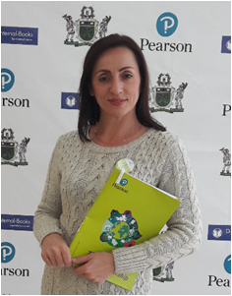

NADIIA KAIDA
kaida.nadiya@ukr.net
Lecturer of the Department of Foreign Philology and Translation
Profile of the scientist in international bases:
Індекси бібліографічних посилань у Google Академія, ORCID, ResearcherID
RESEARCH EXPERTISE: covers problems of translator’s competence acquisition, translation pedagogics, intercultural communication.
COURSES: “Business English in Use. Trade and Economics”, “Practical Course of English Language”.
ACADEMIC APPOINTMENTS:
- Lecturer of the Department of Foreign Philology and Translation, Kyiv National University of Trade and Economics, since 2015
- Lecturer of qualification "specialization of the highest category" pedagogical title "methodology ", Kryvyi Rih, Medical College, 2013-2014
- Lecturer of the department of Ukrainian and foreign languages, Kryvyi Rih, Institute of Economics and Business Administration "National Economic University named after Vadym Hetman", 2007-2013
- Teacher of English, Kryvyi Rih, Secondary Specialized School No. 20, 2005-2007
- Senior Lecturer in the Department of Social and Humanitarian Disciplines, European University of Finance, Information Systems, Management and Business, 2003-2005
- Teacher of English with the qualification "Specialist of the highest category", Kryvy Rih, Central City Lyceum, 2002-2003
- Teacher of English, Kryvyi Rih secondary school № 59, 1991-2002
- Graduated from the Cherkasy State Pedagogical Institute of Foreign Languages, specializing in English language, 1991

ПІДВИЩЕННЯ КВАЛІФІКАЦІЇ
Травень 2016 р. – стажування в ДВНЗ «КНЕУ імені Вадима Гетьмана»
ADDITIONAL ACTIVITIES:
- Member of the International Association of Teachers of English as a Foreign Language (IATEFL), Ukraine.
- Head of the Section of the English Language of the Department of Foreign Philology and Translation, KNUTE
HOBBY: travelling, music.

