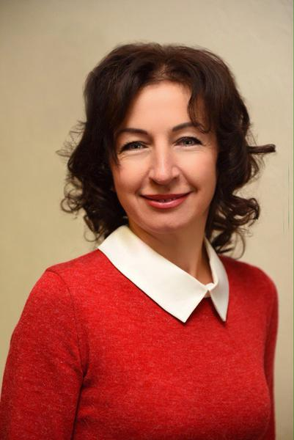 | HALYNA GUSHCHA  gallo4ka@bigmir.net  Doctor of Philosophy in Pedagogy, Associate Professor,  Associate Professor of the Department of Foreign Philology and Translation  Profile of the scientist in international bases:  ORCID, ResearcherID  RESEARCH EXPERTISE: covers the problems of modern methodology of foreign language teaching/ learning, blended learning technology, motivation as the method of encouraging students.  COURSES: “Foreign Language for Specific Purposes”, “Business Foreign Language”, “Foreign Language Professional Communication”, “Foreign Language of Speciality”.
ACADEMIC DEGREES:
- Associate Professor in Foreign Language Training (English), 2006.
- PhD in Pedagogy, 2004.
- Moscow Pedagogical University, Foreign Languages Department. Higher education diploma: Teacher of English and French Languages, 1992.
ACADEMIC TITLES:
- Associate Professor, 2006
ACADEMIC APPOINTMENTS:
- Associate Professor of the Department of Foreign Philology and Translation, Kyiv National University of Trade and Economics, since 2016
- Head of Foreign Languages Department, Ukrainian State University of Finance and International Trade, 2012-2016
- Professor of Foreign Languages Department, National Academy of Internal Affairs, 2010-2012
- Head of Languages Training and Legal Linguistics Department, Academy of Management of the Ministry of Internal Affairs of Ukraine, 2006-2010
- Associate Professor of English Language Department, Kyiv National University Named After Taras Shevchenko, 2007-2011
- Head of Languages Training Department, Kyiv Law Institute of the Ministry of Internal Affairs of Ukraine, 2002-2006
- Senior Lecturer of Foreign Languages Department, Kyiv Institute of Internal Affairs, 1995-2002
- Lecturer of Ukrainian and Foreign Languages Department, Kyiv Institute of Internal Affairs, 1994-1995

AWARDS AND HONOURS:
- Certificate of Appreciation, the Ministry of Education and Science of Ukraine, 2015
- Certificate of Appreciation, Ukrainian State University of Finance and International Trade, 2015
- Certificate of Appreciation, Kyiv Junior Academy of Sciences for young scholars, 2014
- Certificate of Honour, the Ministry of Internal Affairs of Ukraine, 2010
- Certificate of Honour, Academy of Management of the Ministry of Internal Affairs,2010
- Certificate of Appreciation, Academy of Management of the Ministry of Internal Affairs,2010
LIST OF PUBLICATIONS:
http://hushchagalyna.blogspot.com/
ADDITIONAL ACTIVITIES:
- membership in the work of foreign philology and world literature department of Kyiv Junior Academy of Sciences for young scholars,2012-2014
HOBBIES: psychology, literature

