OKSANA SOSHKO
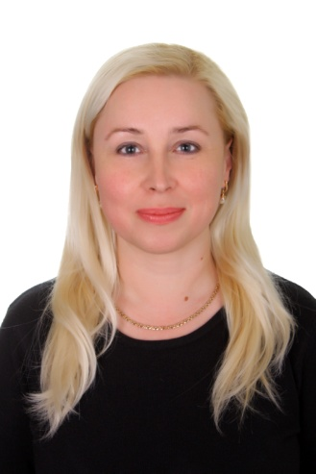
ok_soshko@ukr.net
Candidate of Philology,
Associate Professor of the Department of Foreign Philology and Translation
Profile of the scientist in international bases:
Google Scolar
ORCID
ResearcherID

RESEARCH EXPERTISE: Phraseology, semantics, lexicology, general linguistics.
COURSES:
Foreign Language for Professional Purposes (English)
Practical Course of the First Foreign Language (English)
Business Foreign Language

ACADEMIC DEGREES:
- PhD in Philology, Taras Shevchenko National University of Kyiv, 2014
- MS, National Pedagogical Dragomanov University, 2003

ACADEMIC APPOINTMENTS:
- Associate Professor of the Department of Foreign Philology and Translation, Kyiv National University of Trade and Economics, since 2016
- Associate Professor of the Department of Modern European Languages, Kyiv National University of Trade and Economics, 2015-2016
- Postgraduate student of the Institute of Linguistics named after. O. Potebnya of the National Academy of Sciences of Ukraine, 2009-2013
- Senior Lecturer of the Department of Foreign Languages, Academy of Municipal Administration, Kyiv, 2007-2015
- Lecturer of the Department of Foreign Languages, Academy of Municipal Administration, Kyiv, 2005-2007
- Lecturer of the Department of Foreign Languages, Kyiv Institute of Investment Management, 2003-2005
LIST OF PUBLICATIONS:
Google Scolar
ADDITIONAL INFORMATION
- Member of IATEFL Ukraine, since January, 2019.
- Computer skills: MS Office (Word, Excel, PowerPoint, Outlook) - confident user
HOBBY: travelling, reading, self-education

