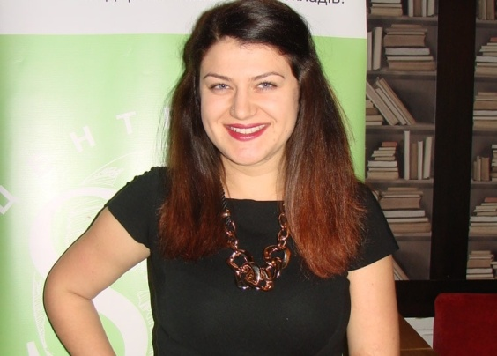
KATERYNA BOROVYK
E-mail: Pani_Kasia@ukr.net
Lecturer of the Department of Foreign Philology and Translation

Profile of the scientist in international bases:
Researcher ID, ORCID
RESEARCH EXPERTISE: innovative methods of teaching foreign languages
COURSES: “second Foreign Language (Polish)”.
ACADEMIC DEGREES:
MS, Taras Shevchenko National University of Kyiv, 2010.
BS, Taras Shevchenko National University of Kyiv, 2009.
ACADEMIC APPOINTMENTS:
Lecturer of the Department of Foreign Philology and Translation, KNUTE, since 2017
AWARDS and HONORS:

LIST of PUBLICATIONS:
Abstracts, published in the materials of conferences – 2 abstracts;
ADDITIONAL ACTIVITIES:
Head of the Section of the Polish Language of the Department of Foreign Philology and Translation, KNUTE
HOBBIES: Literature, travelling, foreign languages.

